Date: 24/12/2025

Automatic unpacking machine
Solution quotation

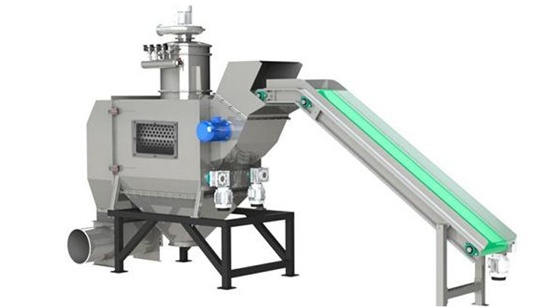

Equipment Introduction

The JX Series fully automatic bag openers offer improved performance and higher reliability. Featuring a fully modular design, the new equipment is smaller in size, occupies less space, and allows for custom installation. The equipment utilizes PLC and touch screen control, offering a high degree of automation. A linkage control interface facilitates full-line automated control and enhances the level of protection.

1.Requirements for use:
Suitable Industries | Chemical, Food, etc.
Material | Powder and Granular
Packing Size | 25kg
Packaging Materials | PP Bag, PE Liner Bag

2.Equipment features:
Suitable for large spaces, large unpacking volumes, and a closed, clean unpacking process with no dust spillage.

3.Schematic description:
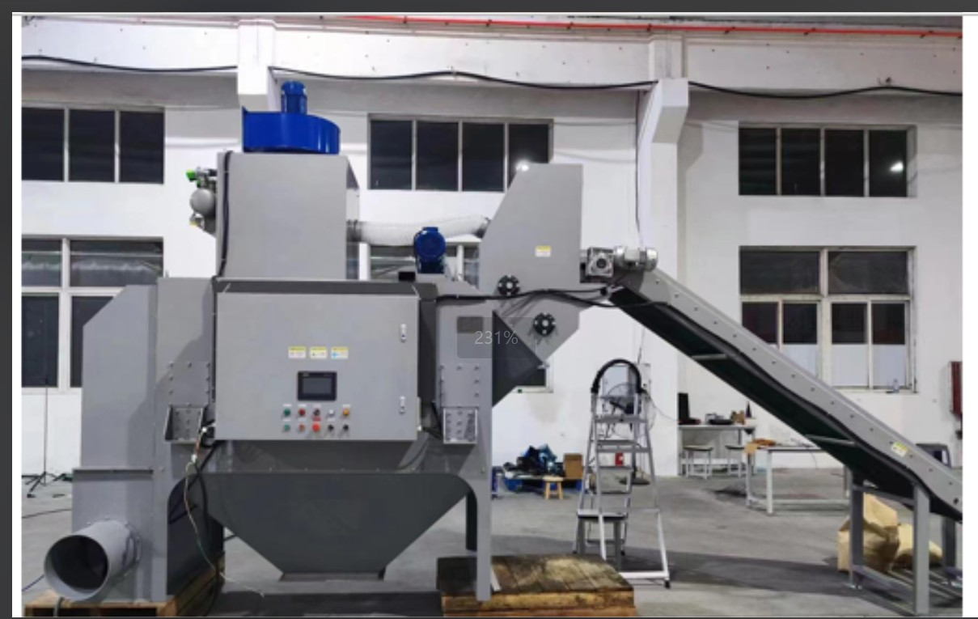

4.Component Description:
No. | Component Name | Description
1 | Main Frame | 1. Main structure of the equipment: carbon steel  2. The main body of the bag unpacker that contacts the material is 304 stainless steel
2 | Cutting Blades | 1. Bag breaker blade uses 12CrMoV  2. The cutting blade uses a circular blade, driven by a motor for rotary cutting
3 | Dust Removal Device | 1. Negative pressure dust removal  2. Made of carbon steel
4 | Waste Bag Collector | 1. Responsible for compressing and collecting waste bags. Made of carbon steel  2. The waste bag collector uses a motor-driven screw extrusion method to effectively reduce the volume of waste bags
5 | Discharge Hopper | 1. Responsible for collecting temporarily stored materials. Main body made of 304 stainless steel  2. The discharge port is connected to the lower end of the user
6 | Control Cabinet | 1. Responsible for the equipment control unit  2. Made of carbon steel, dust-proof design, IP55 protection level  3. Siemens PLC control
7 | Weighing hopper | Weighing hopper：1000L，Meletorado  Delivery method：Vacuum conveying  Pipe connector：DN300，Pipes can be linked according to size, and additional charges will be charged based on the length of the delivery
8 | Belt conveyor | 1 Set，The size needs to be designed according to the on-site environment
9 | Robot | Robot base: 1000 * 1000 * 800 carbon steel  Visual System (Mecamand)

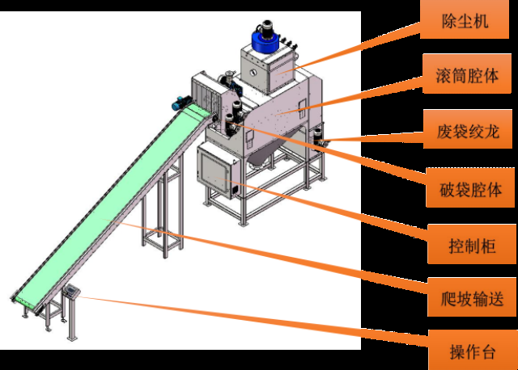
Dust Removal Device

Drum cavity

Waste Bag Collector

Broken bag cavity

Control Cabinet

Belt conveyor

operating table

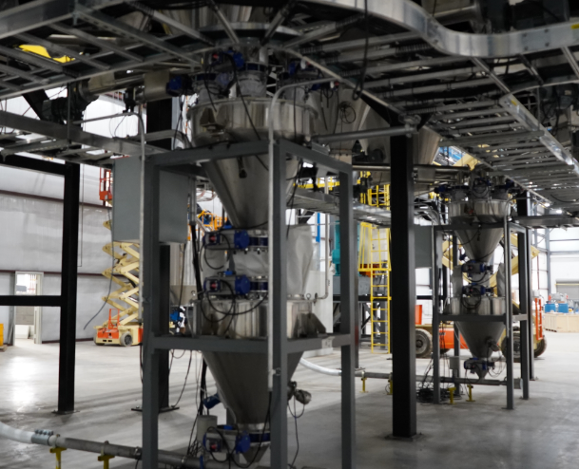

Weighing hopper

5. Technical Features:
1) Intelligent Control: PLC with built-in programming, adjustable unpacking speed, and automatic fault alarm
2) Automatic Waste Bag Collection: Empty bags are automatically collected, squeezed, and bagged via a waste bag collector
3) No Bag Debris: For single- or multi-layer bags such as PE/laminated woven bags, bag debris is removed by a built-in filter, virtually eliminating any bag debris from entering the material
4) No Internal Residue: The equipment features a zero-dead-spot design for highly fluid granular materials, ensuring minimal internal accumulation and preventing cross-contamination between different materials
5) Highly Compatible: The equipment is suitable for most single-layer granular materials that are palletized manually or mechanically
6) Easy Maintenance: Access doors are located in multiple locations, allowing for convenient external access to various components
7. Technical Parameters
1) Processing Capacity | Approximately 400 bags/hour, with a high empty rate.Two robotic arms are required to cooperate, and the production capacity also depends on the material fluidity. The production capacity of one robotic arm is approximately 200 packages per hour,
2) Empty Rate | Approximately 95%-99.9%
3) Equipment Power | Approximately 8.5kW/380V per unit (depending on configuration)
4) Compressed Air | Maximum 150L/minute/0.6MPa
5) Equipment Weight | Approximately 3T per unit (depending on configuration)
The above technical parameters may vary depending on equipment specifications
8. Automation Control System
1) The automatic control system utilizes a Siemens PLC(WP231) numerical control system to control the equipment's automatic operation, enabling one-touch start and stop
2) The touchscreen allows for adjustment and setting of various operating parameters
3) The equipment is highly reliable, with self-diagnosis, alarms, and logging of equipment failures.
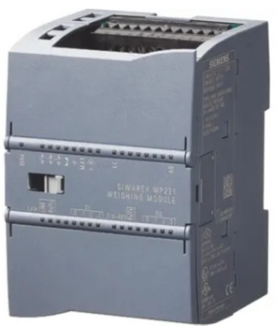
9. Equipment Safety
1) Exposed transmission components are mechanically protected, and all inspection doors and electrical cabinet doors are lockable.
2) A paddle-type level sensor is installed at the lower hopper to monitor the material level within the equipment. Equipment operation will be suspended upon a material level alarm.
3) Interlocking control is implemented between various components of the equipment to prevent misoperation and ensure the safety of both equipment and personnel.
4) The control system utilizes three levels of password protection to prevent misoperation by non-professionals.
5)Equipped with fences and safety locks, the equipment will stop running when personnel enter.
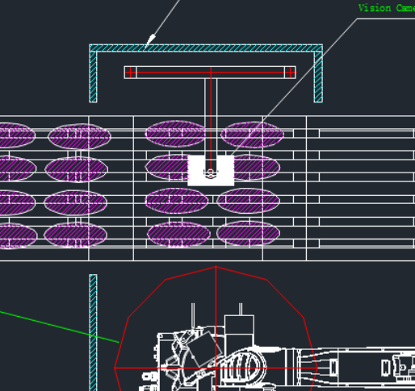
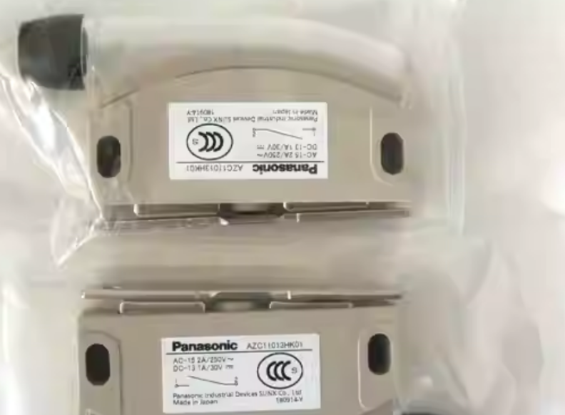
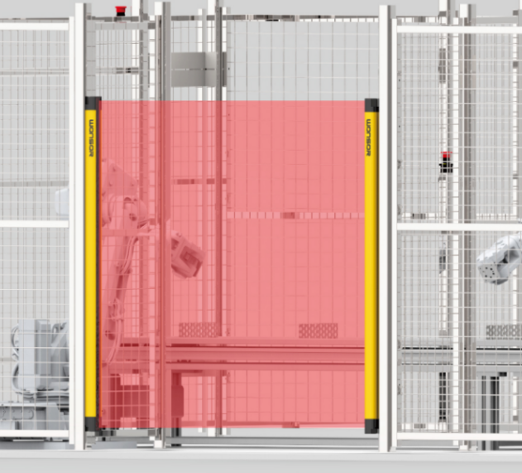
Quotation list：

NO. | Main Equipment List |  | QTY | Unit Price(RMB) | Total Price(RMB)
1 | Automatic unpacking machine(PLC upgrade) |  | 1 set | 835,000 | 835,000
2 | Weighing hopper |  | 1 set | 835,000 | 835,000
3 | Safety facilities |  | 1 set | 835,000 | 835,000
4 | Conveyor |  | 1 set | 835,000 | 835,000
Total Amount Fob Qingdao Price (RMB) |  |  |  | 835,000
Optional Equipment
1 |  | Kuka Robot (including suction cup and  vision system) | 1 set | 525,000 | 525,000

Commercial Terms and Condition：
Country of Origin:China
Terms of Delivery :Fob Qingdao Price, all of the machine price is based on Fob Qingdao Price
Offer Date: 2025.12.23
Offer Validity: 7 DAYS
Delivery time: 90 days after received down-payment.
Terms of payment:
%40 down payment by T/T -> bank fees including those in China in Buyer`s charge
%55 payment before shipment
%5 Payment within one week after arrival
Beneficiary`s Bank Information:
BENEFICIARY’S BANK: BANK OF CHINA, ZHANGJIAGANG SUB-BRANCH
SWIFT CODE: BKCHCNBJ95L
BANK ADDRESS: 111 Middle Renmin Road, Zhangjiagang City, China
BANK TEL: +86-512-58108192
BENEFICIARY’S ACCOUNT NUMBER:544369534601
BENEFICIARY’S TEL: +86 512 56303759
BENEFICIARY’S NAME:STARS UNION EQUIPMENT TECHNOLOGY (JIANGSU) CO., LTD
BENEFICIARY’S ADDRESS: 215625, Plant A18 Jinfeng Technology Innovation Park, Zhangjiagang, Jiangsu Province, PRC

WARRANTY:Mechanical parts& Electrical Parts :
12 months from starting and anyhow no longer than 14 months from the date of delivery
for the parts considered by the manufacturer to be defective.
Parts of normal wear are excluded from warranty.
Force Majeure
Instances of force majeure which prevent contractual partners wholly or partially in the
performance of their obligations, release the contractual partners from their performance
obligations until elimination of the force majeure and to the extent of its effect. The
contractual partner who is affected by an instance of force majeure, shall advise the other
party of this without delay. The impossibility of an adequate supply with raw and auxiliary
materials as well as with additional parts, the impossibility of procuring means of
transportation, strikes and lockouts shall be equivalent to an instance of force majeure.
Coming into force of Contract
Immediately after signing the contract and the received the down payment.
Sellers delivery-obligation will start upon receipt of down payment
Exclusion Clauses:
Civil works
Electrical cables and trays connecting the machines with the power distribution box
Installation and starting on the purchaser ’s premises. Cranes, minor metalwork and
equipment that may turn out to be necessary during installation and starting on site.
Labor to aid our technician when starting, including but not limited to Air Tickets, Train, Taxi
and other transportation fee; 150$ Subsidy for each installation team member; 3-stars hotel
or no less than 50$/night hotel or apartment; Chinese food or no less than 30$ meals
subsidy per day. what else not specified in this offer.


Representatives of the Seller
Name: Rose Zhang
Title: Project Assistant

